# Introduction to GIS with ArcGIS

Stacey Maples – Geospatial Manager – Stanford Geospatial Center – [stacemaples@stanford.edu](mailto:stacemaples@stanford.edu)

David Medeiros – GIS Instruction & Support Specialist - Stanford Geospatial Center - [davidmed@stanford.edu](mailto:davidmed@stanford.edu)

This introductory session will focus upon the fundamental concepts and skills needed to begin using Geographic Information Systems software for the exploration and analysis of spatial data using the ArcGIS platform.  Topics will include:

* What is GIS?
* Spatial Data Models and Formats
* Projections and Coordinate Systems
* Basic Data Management
* The ArcMap User Interface
* Simple Analysis using Visualization.

## GIS Resources:

Stanford Geospatial Center website - <http://gis.stanford.edu/>

Stanford GIS Listserv - <https://mailman.stanford.edu/mailman/listinfo/stanfordgis>

Esri ArcGIS 10.2 Help - <http://resources.arcgis.com/en/help/main/10.2/>

## Download Tutorial Data

1. In a browser, go to <https://stanford.box.com/SGCIntroGIS> and click on the drop-down arrow to the right of each folder to download individual datasets. Save the Dataset to your Desktop.
2. Right-click on the resulting **\*.zip** file and select Extract All…
3. Accept all defaults to extract the data file.

## Open ArcMap and Explore the User Interface

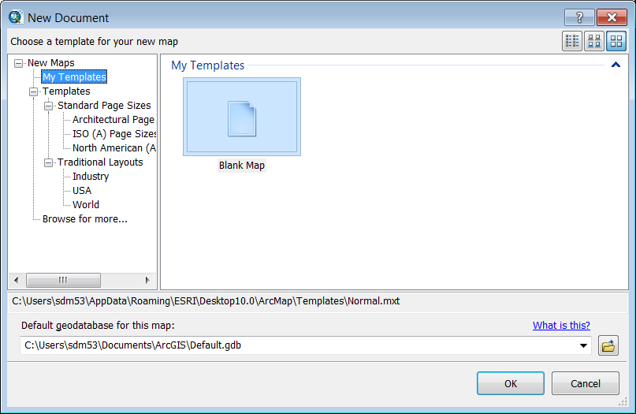ArcMap is the 2D mapping component of the ArcGIS Suite of software. Most of your basic data management and analysis will be done in using ArcMap. The first thing we want to do is **Open** ArcMap and get familiar with the Default User Interface.

1. In Windows, go to the Programs menu and find the ArcGIS Program Group, then select ArcMap to Open ArcMap.
2. You should be presented with the **New Document** dialog window, with the **Blank Map** template selected by default. Simply click OK to accept this template.

You should then be presented with something like the interface you see below:

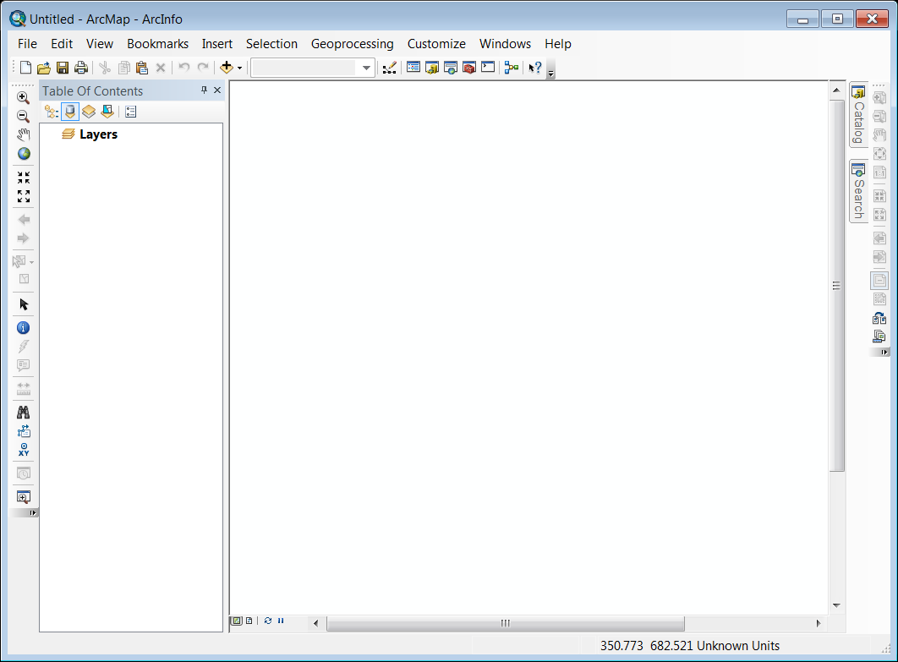

The View Toolbar

The Table of Contents

**The Data Frame**

Tabbed Windows

The Main Menu

The Standard Toolbar

The Layout Toolbar (Disabled)

The Tools Toolbar

### The Basic Components of the ArcMap Interface

The ArcMap interface is made up of three basic components:

**The Data Frame** – The Data Frame is where your geographic datasets will be visualized

**Tabbed Windows**:

* **The Table of Contents** – The Table of Contents is the most important of the ‘Tabbed Windows” set, and is visible by default. This window is where you will interact with your data most of the time. As you add geographic and non-geographic datasets to your **Map Document**, they will show up in the **Table of Contents** as **Layers**. Much of your work in **ArcMap** will be initiated by right-clicking on one or more of the **Layers** in the Table of Contents.
* **Search Window –** The **Search Window** shows up, by default, as a **Tabbed Window.** This window is used to search for **ArcToolbox Tools, Map Documents** and **Data** (provided you have enabled indexing for your data folders, which will be covered in a later lab).
* **Catalog Window –** The **Catalog Window** functions much as Explorer does in Windows. In this window, you can create connections to drives, folders and network resources for use in ArcGIS. Many of the tasks related to data maintenance (creating empty **shapefiles**/**feature classes**, new **Geodatabases**, etc…) are performed using the Catalog Window. This window acts as a ‘lite’ version of the more fully featured **ArcCatalog** component of the **ArcGIS** **Suite**.
* **Tables, Imagery Analysis Window, etc…** - There are a few other windows that can be ‘Tabbed’ in ArcMap. We will cover these as needed in the tutorials.

**Toolbars –** There are literally dozens of **Toolbars** in **ArcMap**. Each of these toolbars is composed of a set of buttons that launch tools that are related to a GIS task of some sort. For example, the oh-so creatively named **“Tools” Toolbar** is composed of the most often used tools for navigating in the **Data Frame** and basic selection and querying of data layers. Toolbars can be enabled in several ways, but the easiest is to simply right-click in an empty area of the toolbar part of ArcMap and select the toolbar you need.

### Enabling and Rearranging the User Interface/Toolbars

#### Enable Effects Toolbar

1. On the **Main Menu**, go to **Customize>Toolbars>Effects Toolbar** to enable the **Effects Toolbar**.
2. 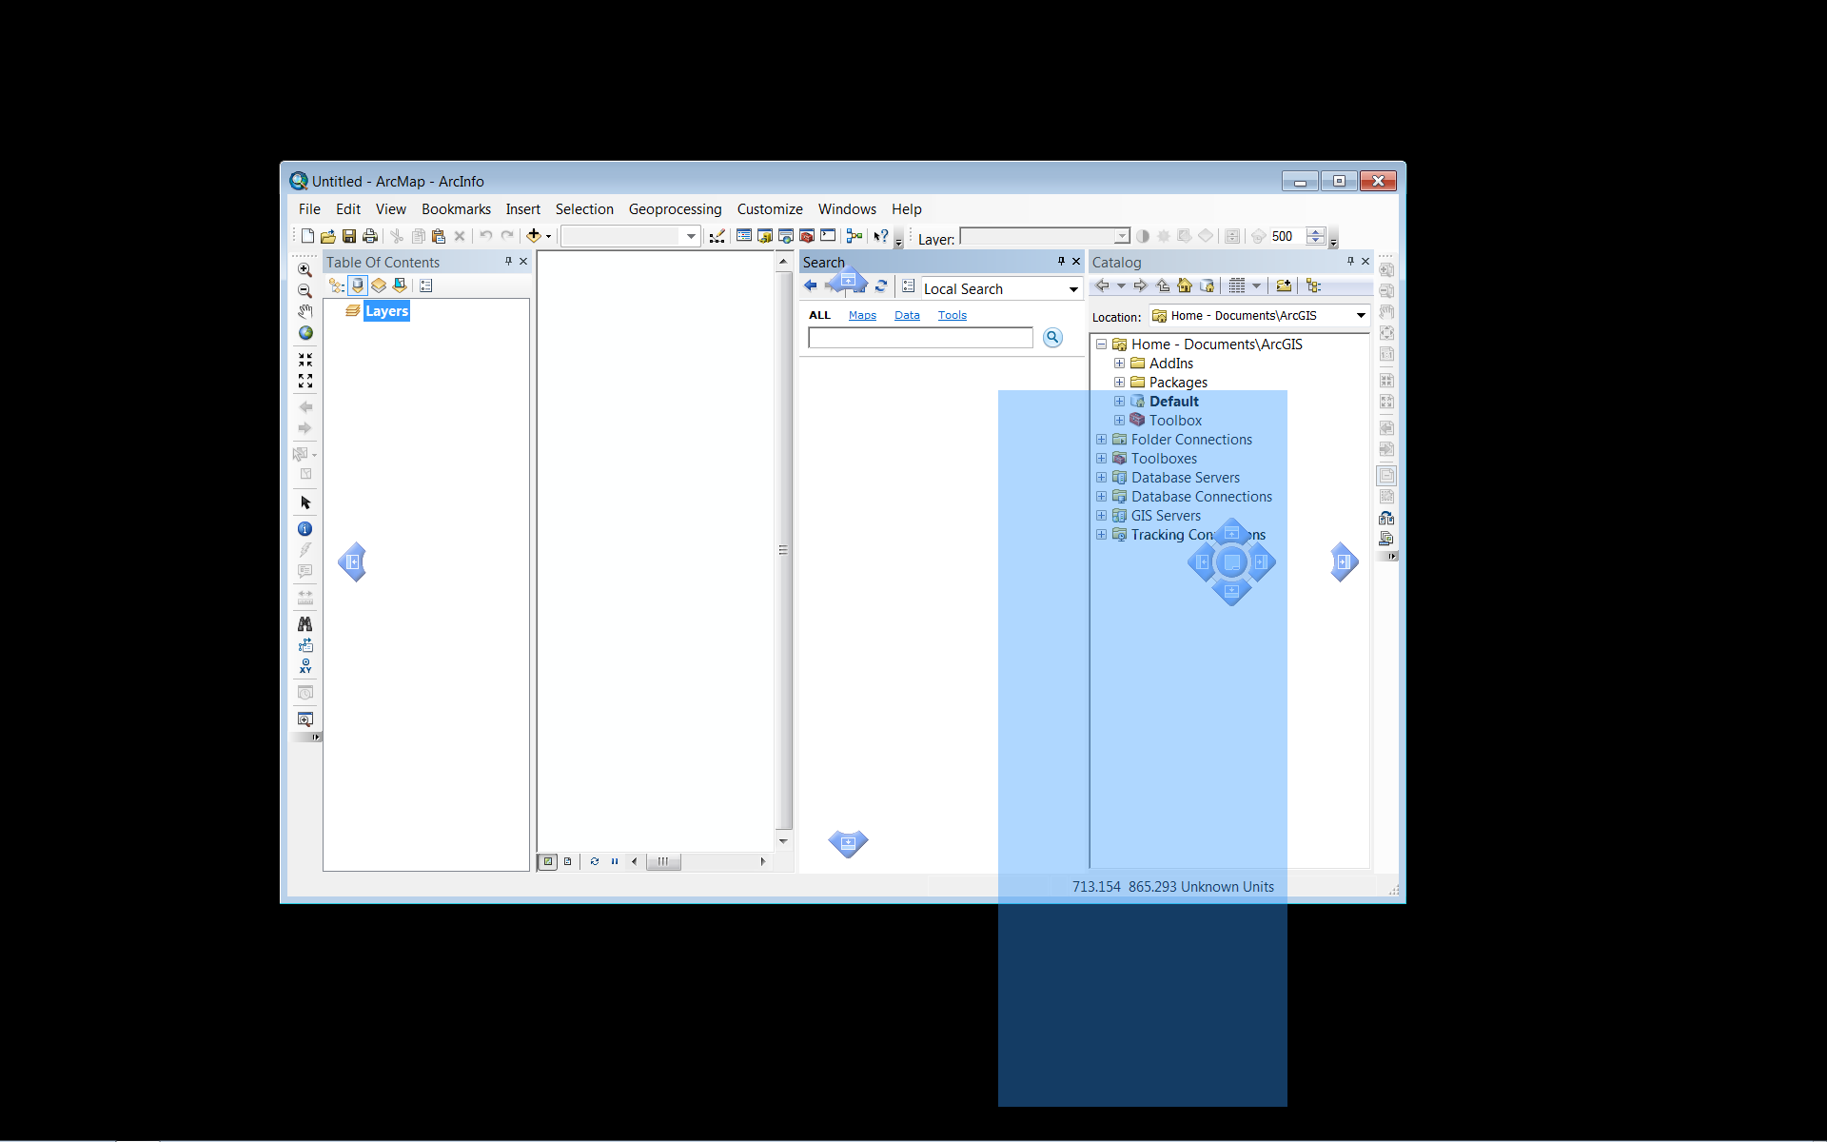C:\Users\sdm53\Pictures\ScreenCaps\EX01_World_Pop\03 Effects Toolbar undocked.png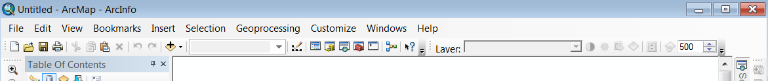Click and Drag the Effects Toolbar just to the right of the Standard Toolbar, and note that you can “dock” toolbars at the top, bottom and sides of the ArcMap interface.
3. We will make use of this toolbar later in the tutorial.

### Interacting with Tabbed Windows

1. 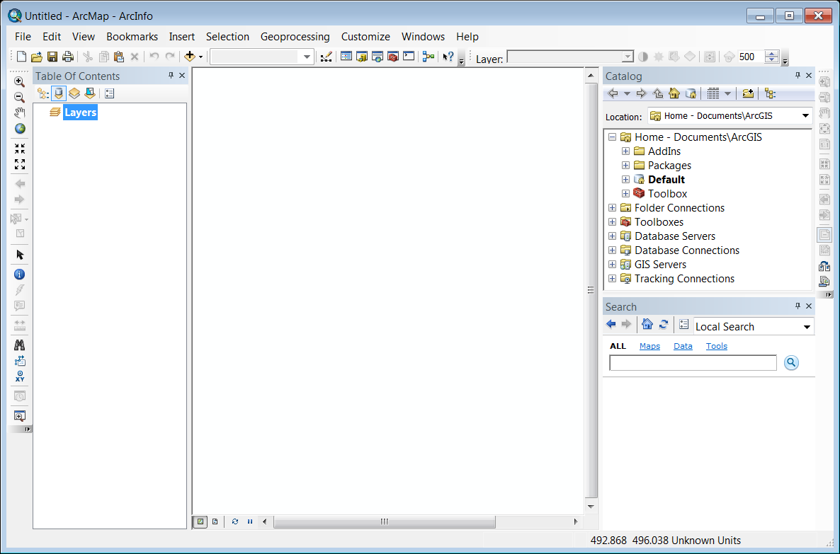Move your cursor over the **Catalog Tab**, just to the right side of the **Data Frame**. Note that the **Catalog Window** expands.
2. Click on the **Auto Hide Pushpin Icon** at the top of the **Catalog Window** to ‘pin’ the window open.
3. Now, move your cursor over the Search Tab to expand the **Search Window**.
4. Click on the **Auto Hide Pushpin Icon** at the top of the **Search Window** to ‘pin’ the window open.
5. Using the **Search Window’s Title Bar**, Click and Drag the **Search Window** away from it’s docked position. Note the ‘**Docking Arrows**’ that appear as you move the window.
6. Drag the **Search Window** around to each of the **Docking Arrows** and note the effect on the blue **Docking Preview** rectangle.
7. Finally, drop the **Search Window** on the bottom **Docking Arrow** of the “Flower” that appears when you drag it over the **Catalog Window.**

### Explore the “Windows” (Catalog)

1. Using **Windows Explorer**, browse to the **\Introduction to ArcGIS\EX01\_World folder**, where you extracted the EX01\_World.zip file and browse into the **EX01\_World\Data** Folder.

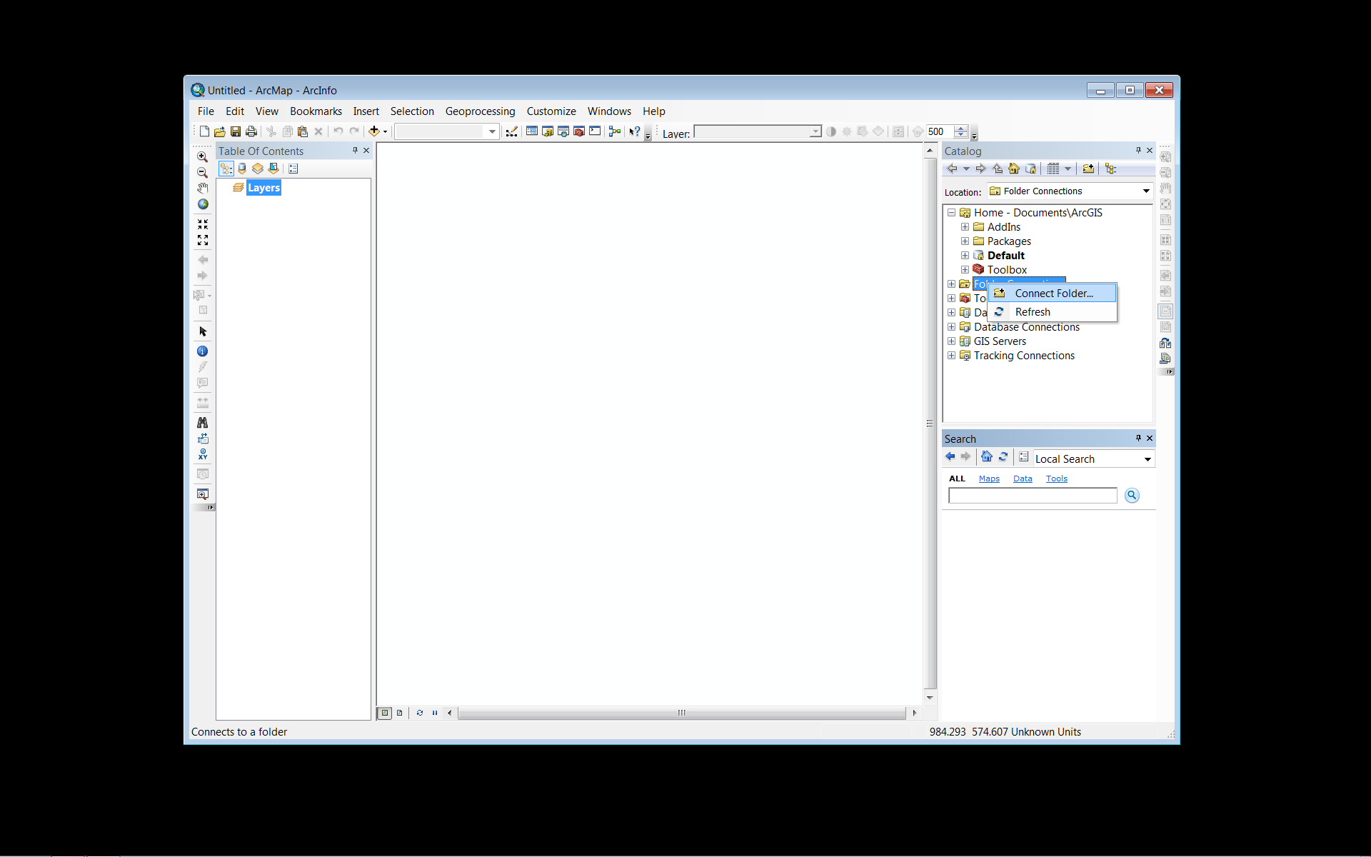Note that, while there are 23 files in this folder, there are actually only 3 Shapefiles and a DBF Table here, as far as ArcGIS is concerned. This is because a Shapefile isn’t really a *file* but a collection of files. *You* are looking at this folder in Windows Explorer in order to illustrate a very important point about many types of geographic data formats: Geographic datasets are often not easily manageable using software not specifically designed for handling GIS data. In the case of the Shapefile, for example, if you wish to rename or move a shapefile, you must move or rename ALL of its component files in exactly the same way, or you can corrupt the shapefile.

1. **Return to ArcMap** and **right-click** on the **Folder Connections** item in the **Catalog Window** and select **Connect Folder**.
2. **Select** the **Desktop** icon at the top and **click OK**.
3. 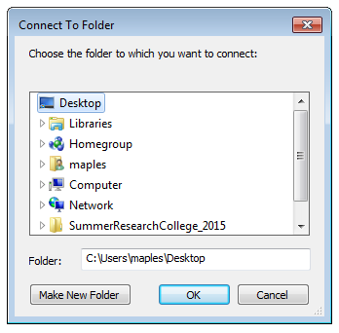**Expand** the resulting **Folder Connection** in the **Catalog** **Window**, and then **expand** the **Workshop Data Folder**.

Note that the Shapefile is much simplified in the ArcMap Catalog Window. Although the Shapefile is still made up of several files, ArcMap seems to know that it’s not a good idea to make you deal with all that, so it simplifies things by only showing you the .shp file. You can copy, paste, rename and many other “Explorer” tasks in Catalog without having to manage a half dozen or more files per dataset.

## Finally, let’s open a Map Document!

You should, in addition to a Data Folder full of shapefiles, have a Map Document in your **\Introduction to ArcGIS\EX01\_World \EX01\_World Folder** called… EX01\_World.mxd. The extension is hidden in Catalog, but the icon looks like this: 

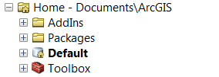

1. **Drag** the **EX01\_World Map Document** into the **Data Frame** of **ArcMap** to open it.

Take a look at the Change to the Top Level “**Home**” Folder in Catalog. It has changed from the Application Default, to the Folder when the Map Document you are working with is stored. Handy, eh!?

### But Wait!

Has something gone awry? Do you see something that looks like this:

### Macintosh HD:Users:maples:Dropbox:Screenshots:Relative Paths Problem.gif

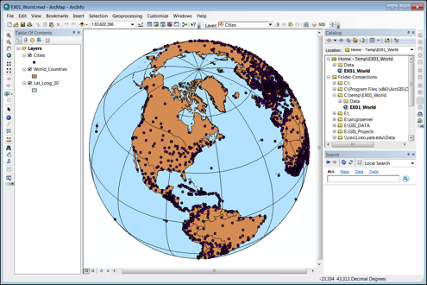You are experiencing the dreaded “**Absolute Paths**” problem, endemic to ArcMap. To fix this issue, do the following:

1. **Right-click** on one of the layers and select **Data>Repair Data Source…**
2. **Browse** into the **Data Folder** of the tutorial dataset and select the shapefile that corresponds to the layer you right-clicked. Click OK

You should find that (because they are all in the same ‘**workspace’**) all of your layers have been repaired and you should see something like the image on the right.

## How to keep broken data links from happening…

### Set Relative Paths (In Options)

Before explaining how to set the Relative Paths Option in ArcGIS, it is instructive to explain a bit more about what exactly a Map Document (.MXD) is, and is not. When you open ArcMap and begin *adding* [with emphasis] datasets and creating symbologies, labeling schemes, etc…, you are creating a Map Document. I emphasize the word “*adding*” here because you don’t really “add” data to a map document. What you are really doing is ***linking*** to the datasets you are interested in. Because you are sometimes working with datasets that are hundreds of megabytes, if not gigabytes, in size, it would be impractical to actually *add* the data to a map document. So unlike, say, a Word Document, a Map Document doesn’t *contain* most of the objects that you add to it, but only links to them.

This is where the **distinction between Absolute and Relative Paths** becomes critical, ***especially if you want to move your project from one machine to another, or keep it on some portable storage device***. By default, ArcGIS uses Absolute Paths to record the location of data that is referenced in a Map Document. This means that if a Map Document in the folder C:\GIS refers to a dataset in the same folder, the map and dataset cannot be moved to ANY other location (even if they are moved together) without breaking the Map Document, since it will be looking for it’s data in the C:\GIS folder. Setting ArcMap to save references to data as Relative Paths alleviates this problem. In the case of the previous example, the Relative Path would discard the part of the data path that was identical to the path to the Map Document (in this case, the C:\GIS\ part), keeping only what was necessary to get *from* the Map Document  *to* the dataset. This means that, as long as the Map Document and dataset remain in the same location *relative to one another* you can move the them without breaking the references to the data recorded in the Map document. That is, you can move the entire GIS Folder (containing the Map Document and Dataset) to any other path, drive or machine and open the Map Document without issue. While it is possible to set this option for individual Map Documents, it is really best to set the option for all Map Documents created with your installation of ArcGIS.

1. 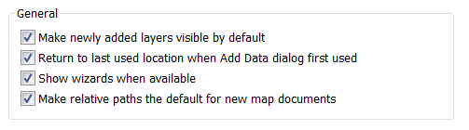On the Main Menu, go to Customize>ArcMap Options
2. Check the Option to “Make Relative Paths the default for new map documents”
3. Click OK

### **C:\Users\sdm53\Pictures\ScreenCaps\EX01_World_Pop\13 TOC Display Order.png**The Data Frame and its Properties

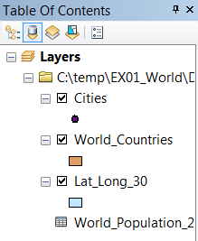Now take a look at the **Table of Contents**. You should see a “Layers” item, followed by 3 Layers corresponding to the shapefiles in your Data Folder. The “Layers” item at the top of the TOC represents the Data Frame, within which all of your layers are contained. What you don’t see is that **DBF Table**, although it is actually included in the Map Document, too. This is because you are currently looking at the “List by Drawing Order” view of the TOC. Since the Table doesn’t have an explicit geographic component (it’s just a table of data), it isn’t shown in this view.

1. **Click** on the **List By Source button** (the second button from the left at the top of the TOC).

Note that the **World\_Population\_2007** table is now listed at the bottom of the TOC. Note, also, that the layers are organized underneath the path at which they are located. If this Map Document contained links to datasets in other locations, they would be listed under that path or network address.

### C:\Users\sdm53\Pictures\ScreenCaps\EX01_World_Pop\15 Data Fram Coordinate System.pngProjections and Coordinate Systems in ArcMap

The datasets in this Map Document are all in the same Projection/Geographic Coordinate System, though it is not the one being used to display the data in the **Data Frame**, currently. In ArcMap, datasets can (and in most cases, must) have their own explicitly defined **Projection/Coordinate Systems**, while the **Data Frame** can have a completely different Projection/Coordinate System. This allows you to add geographic datasets with different **Projection/Coordinate Systems** to **ArcMap**, by treating the **Data Frame’s Projection/Coordinate System** as the Map Document’s Lingua Franca, projecting (on the fly) all of the datasets to the Data Frame Projection. While this may seem convenient, it comes at a cost: Map Documents that make use of this type of on-the-fly projection render the data in the Data Frame at a much slower rate than those in which the datasets and the Data Frame all share the same Projection/Coordinate Systems. Additionally, disparate Projection/Coordinate Systems can cause major issues and errors when analyzing across layers such as in **geoprocessing** that requires overlay and transfer of attributes across layers. For this reason, it is best to select a Projection/Coordinate System that is suitable for your particular analysis and geographic scale, and project all of your data to the same.

### Change Coordinate System to GCS WGS 1984

1. **Right-click** on the **Layers** Item at the top of the **Table of Contents** and select **Properties…**
2. **Click** on the **Coordinate system Tab** and expand the **Layers Folder** in the “**Select a Coordinate System**:” panel.
3. **Expand** the **Layers Folder** and select the **GCS\_WGS\_1984 Projection file**. **Click OK**.
4. **Click Save**

What you have just done is reassigned the coordinate system of the **Data Frame** to that of the **Cities Layer** in your **Map Document**. This (**GCS WGS 1984**) is actually the coordinate system of all of the layers in your **Map Document**, so you should experience an increase in drawing performance, since **ArcMap** is no longer projecting these layers on-the-fly to the **World from Space projection** (which was chosen for its extremity, in this case). The result of this change should be a fairly substantial change to the view on the Data Frame.

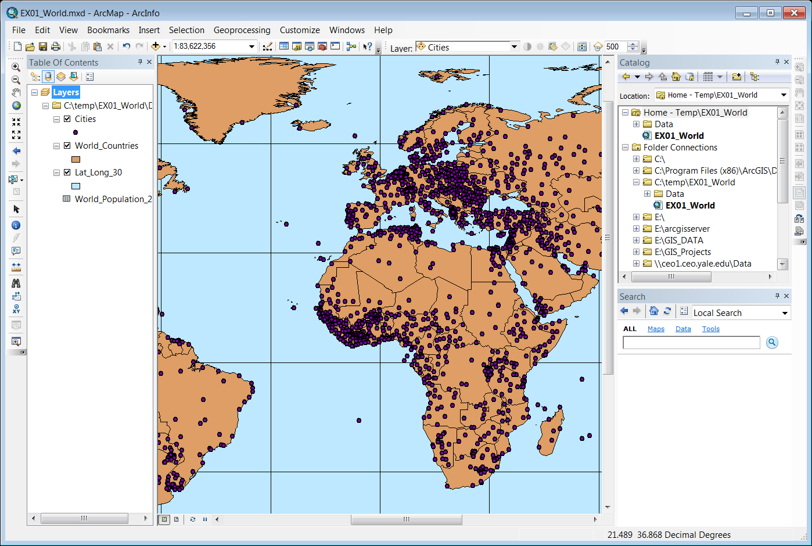

## Explore Navigations Tools and Visibility in Data Frames

Before we begin to explore the properties of individual layer in the Map Document, we will first spend some time getting familiar with the navigation tools in ArcMap. Most of these tools can be found on the “Tools” toolbar, though some of the more useful ones involve right-click context menus of the layers.

### Zoom to Layer

1. **Right-click** on the **Lat\_Lon\_30 Layer**, in the **TOC**, and select **Zoom to Layer**.

Note that this should present you with the entirety of the Lat\_Lon\_30 Layer’s extent.

#### Tools Toolbar Navigation

C:\Users\sdm53\Pictures\ScreenCaps\EX01_World_Pop\20 Tools Toolbar.pngThe **Tools Toolbar** provides the bulk of the tools for navigation in the **Data Frame**. Most of them are fairly obvious. Take a moment to explore each of these tools, and how it works.

1. 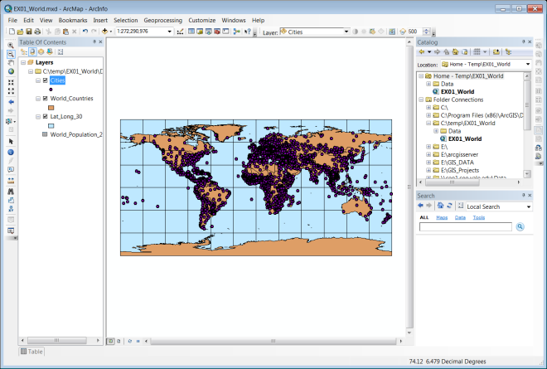C:\Users\sdm53\Pictures\ScreenCaps\Tool Buttons\Zoom in.png The **Zoom Tool** works exactly as you would expect. Click on the Zoom Tool, and drag a box to enclose the Continental United States. You can also single-click with this tool to use it as a Fixed Zoom Tool.
2. C:\Users\sdm53\Pictures\ScreenCaps\Tool Buttons\Zooom out.png The **Zoom Out Tool** isn’t quite as intuitive as the Zoom Tool. Click on the Zoom Out Tool and Drag a Box over the State of Texas. ArcMap will fit the current extent of the Data Frame into the box you just defined. You can also single-click with this tool to use it as a Fixed Zoom Tool.
3. 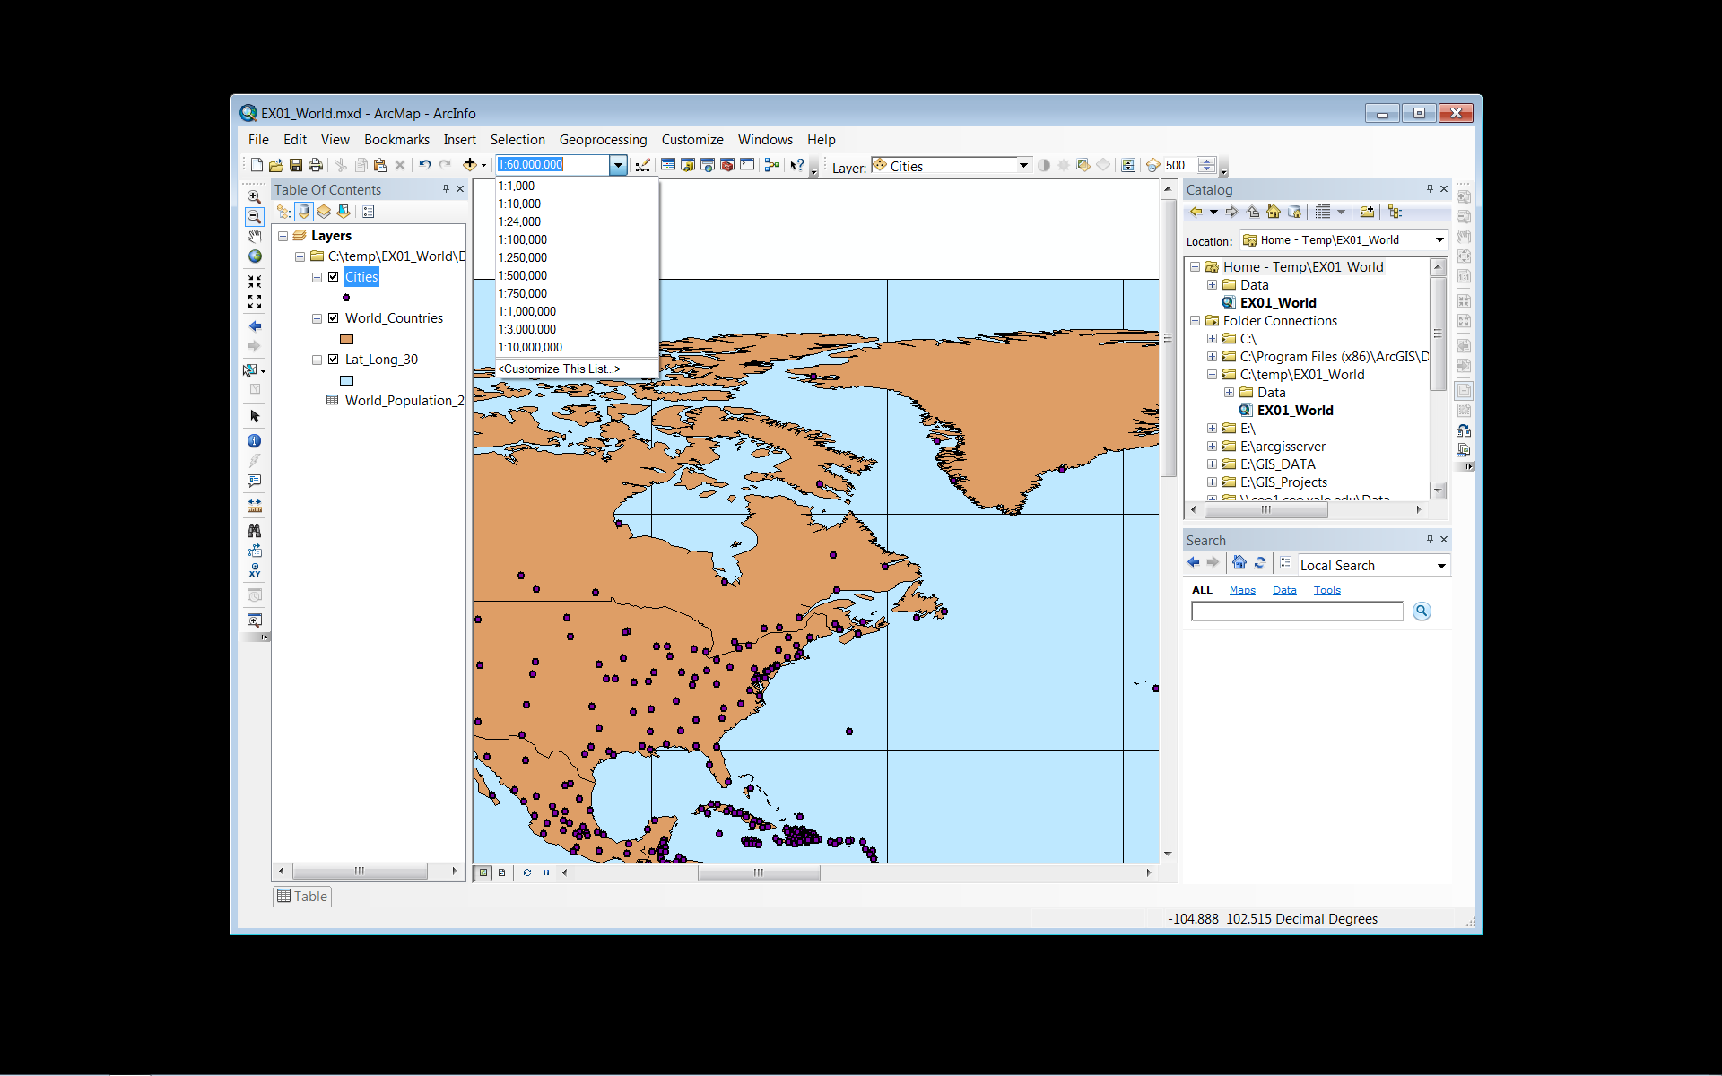C:\Users\sdm53\Pictures\ScreenCaps\Tool Buttons\Pan.png The **Pan Tool** changes the Extent of your Data Frame, without changing the scale. Click on the Pan Tool and use it to move around the Data Frame.
4. C:\Users\sdm53\Pictures\ScreenCaps\Tool Buttons\Full Extent.png The **Full Extent Button** zooms you to the full extent of the layer in your Map Document with the largest spatial extent. This can sometimes be problematic if you are working at a local leve, but using one or more layers that are global in extent (for example, many of the network basemap services).
5. C:\Users\sdm53\Pictures\ScreenCaps\Tool Buttons\Fixed Zoom in.png The **Fixed Zoom In Tool** works as expected. Click on the Fixed Zoom In Tool and take a look at the Scale Dropdown on the Standard Toolbar and note that the Fixed Zoom In Tool is tied to the Scale Values in this dropdown.
6. C:\Users\sdm53\Pictures\ScreenCaps\Tool Buttons\Fixed Zoom Out.png The **Fixed Zoom Out Tool** works as expected. Click on the Fixed Zoom Out Tool and take a look at the Scale Dropdown on the Standard Toolbar and note that the Fixed Zoom In Tool is tied to the Scale Values in this dropdown.
7. 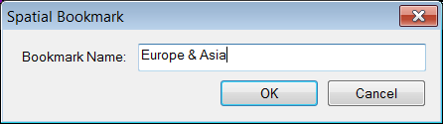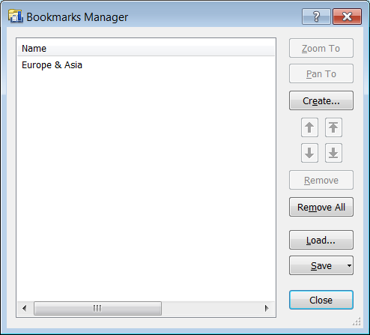C:\Users\sdm53\Pictures\ScreenCaps\Tool Buttons\Back.png The **Back Button** works much like its analogous tool in your browser, allowing you to step back through previous changes in Scale/Extent. This tool is particularly useful if you change your Data Frame Extent inadvertently.
8. C:\Users\sdm53\Pictures\ScreenCaps\Tool Buttons\FOrward.png Again, the **Forward Tool** is analogous to the browser forward button, stepping forward through the Scale/Extents in your project history.

### Bookmarks

One of the most useful navigation tools is the ability to create **spatial Bookmarks**.

1. Using the **Zoom Tools** on the **Tools Toolbar**, **Zoom** your **Data Frame** view to the **European/Asian Landmass**.
2. On the **Main Menu**, go to **Bookmarks>Create…**
3. **Name** your **Bookmark** “**Europe & Asia**” and **click OK**.
4. **Click** on the **Full Extent Button** C:\Users\sdm53\Pictures\ScreenCaps\Tool Buttons\Full Extent.png.
5. **Return** to **Main Menu>Bookmarks** and **select** your **Europe & Asia** bookmark.

These can even be easily shared or moved from one Map Document to another, too. Returning to the Bookmarks Menu item, you will find a Manage… option, which opens the Bookmark Manager. This manager provided option for reordering, deleting, creating and saving your bookmarks, or selected subsets. Bookmarks are saved as .dat files that can be loaded in other Map Documents.

### Display Order

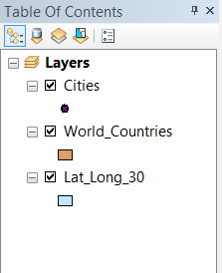

The Layer Order in the Table of Contents determines the order of display in your Data Frame, when it is in the List by **Drawing Order Mode.**

1. 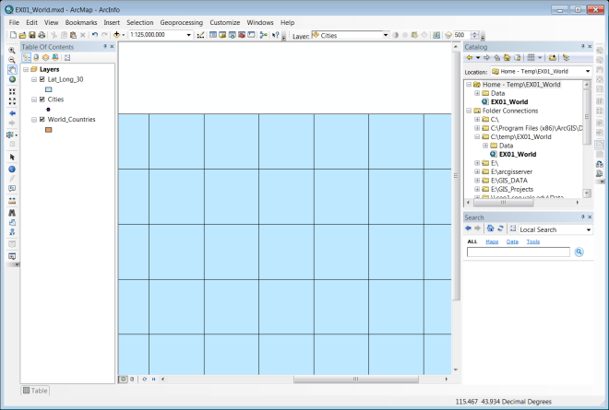If you haven’t already, change your **Table of Contents view** from “**List by Source**” to “**List by Drawing Order**” using the **View Buttons** at the top of the **Table of Contents**.
2. **Click and Drag** the **Lat\_Lon\_30 layer** to the **top** of the **Table of Contents**. Note that the other layers in your Map Document are now obscured.

## Working with Layers & Their Properties

### Layer Visibility

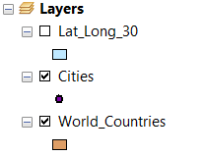The Table of Contents also controls Layer Visibility. You can toggle the Layer Visibility using the checkbox next to each Layer in the Table of Contents.

1. Use the **Visibility Checkbox** next to the **Lat\_Long\_30** Layer to **turn off** the **visibility** of the layer and reveal the other layers again.

### C:\Users\sdm53\Pictures\ScreenCaps\EX01_World_Pop\25 Cities Attribute Table.pngExamining and Selecting by Attributes

The most basic method of analysis in GIS is selection and sub-setting of data by attribute values. Now that the Cities Layer is visible again, we can begin to address the fact that this layer is a bit overpopulated for our purposes. Let’s say we are interested in visualizing the global distribution of cities with populations greater than or equal to 1 million. First we need to see if the data necessary to do this exists in our dataset.

1. **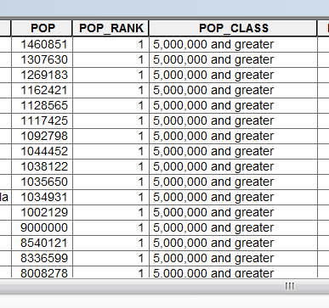Right-Click** on the **Cities Layer** and select “**Open Attribute Table**” to open the **Attribute Table** of the layer.
2. **Click and Drag** the resulting **Table Window** to the **Docking Arrow** at the **bottom** of the **Data Frame** so that it spans the entire width of the **ArcMap** Application Window.
3. **Scroll** to the right until you can see the **POP, POP\_RANK** and **POP\_CLASS Attribute Fields**
4. **Right-click** on the **POP Field Header** and select **Sort Descending.**
5. **Scroll** down through the **Attribute table** to examine the relationship between these three variables.

#### Selecting By Attributes

What we would like to do is select all of the cities in this dataset that have a population of 1 million or greater. This can be accomplished using any one of these three of these variables, but we will use the POP\_RANK variable for the sake of simplicity.

1. 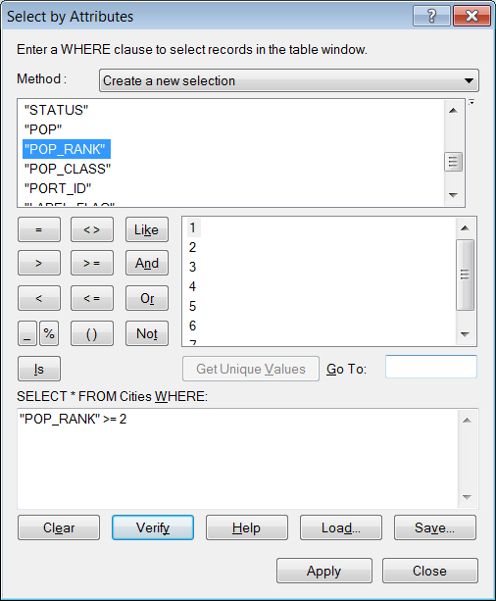On the Upper left corner of the Attribute Table, **find** the **Select by Attributes button** C:\Users\sdm53\Pictures\ScreenCaps\EX01_World_Pop\27 select by attributes button.png and **click** on it.
2. Leave the Method: “**Create a new selection**”
3. Scroll through the list of Attribute Fields and **Double-click** on the “**POP\_RANK**” value to place it into the **SELECT** Argument textbox, at the bottom of the window.
4. **Click** on the “**<=**” **Button** to enter the operator into the **SELECT** **Argument**.
5. With the “POP\_RANK” value still highlighted in the Field List, **click** on the **Get Unique Values** button and double-click on 2 to complete the **SELECT** **argument**.

*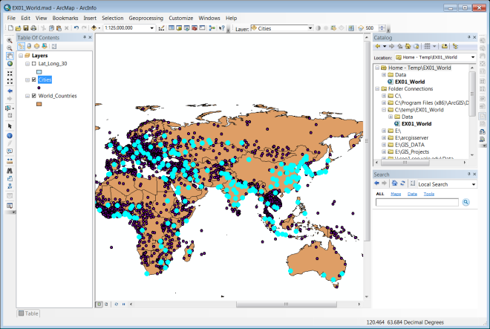Note that you could also simply type any of the components of the SELECT argument, manually, using SQL syntax.*

1. **Click Apply** and **Close** to apply the selection to your Cities Layer.
2. **Scroll** through the Attribute Table and note the records that are selected.
3. Unpin or close the Attribute Table so that you can **observe that the selection from the Attribute Table is also reflected in the Data Frame**.

### Exporting Data

**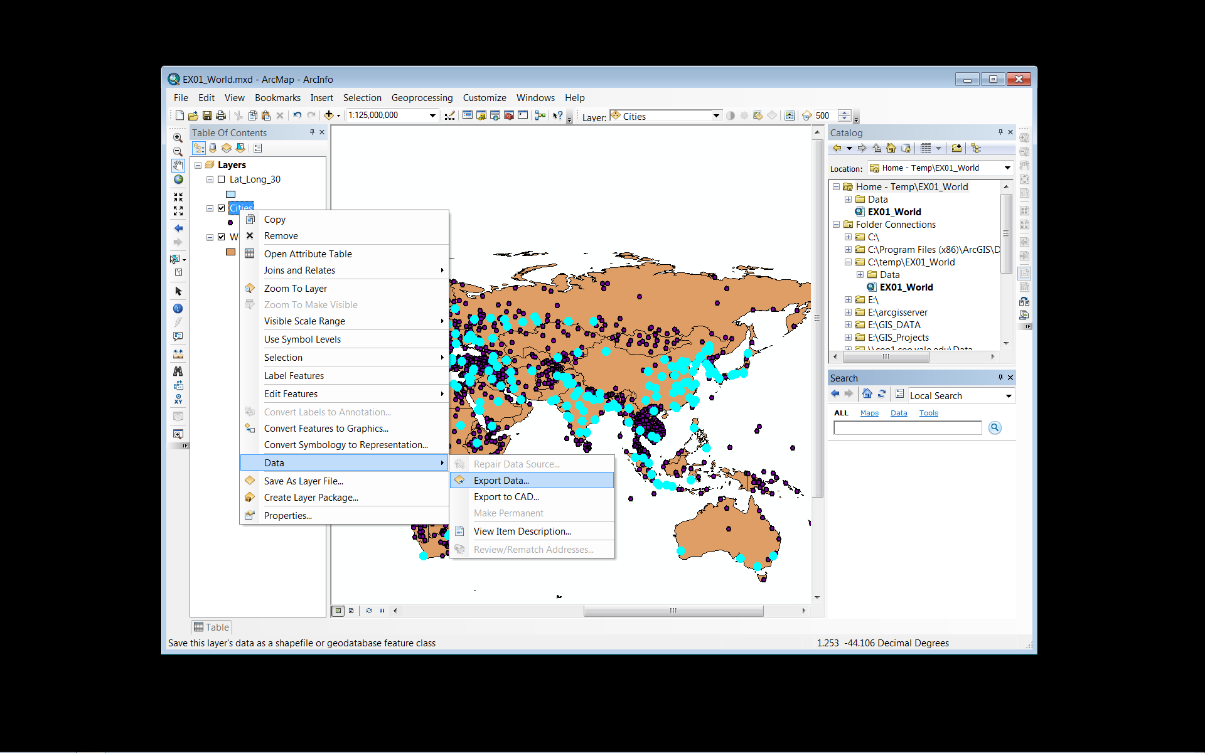**Notice that the Selection looks more manageable that the full dataset. Now you will export this selection as a new shapefile, and bring it back into ArcMap as a new Layer. As you do this, you will take advantage of a sort of “universal” in ArcMap. **Anytime you have selected a subset of one of your data layers ArcMap will only act on that subset while it is active.**  This means that Geoprocessing, attribute calculations, data exports, etc… act as if the active selection is the whole of the dataset. This can come in quite handy.

1. **Right-click** on the **Cities Layer** in the Table of Contents and select **Data>Export Data…**
2. Note that the **Export: Default is Selected Features**
3. **Click** on the **Browse Button** for the Output feature class.
4. 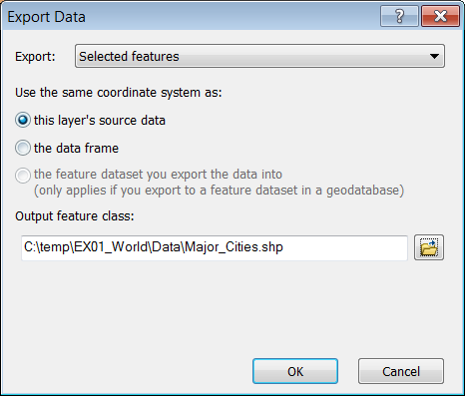Click on the Home Button C:\Users\sdm53\Pictures\ScreenCaps\EX01_World_Pop\30 Home Button.pngand **Browse** into the **Data Folder** to save the Output Feature Class as **Major\_Cities.shp**
5. Change the **Save as type** to **Shapefile** and **Click Save** and **OK** to **Export** the Selected Subset.
6. **Click Yes** when prompted to **add the exported data as a layer** in ArcMap.
7. **Right-click** on the **original Cities Layer** and select **Remove**.

#### C:\Users\sdm53\Pictures\ScreenCaps\EX01_World_Pop\33 City Symbology.pngChange City Symbology

Now we have two classes of POP\_RANK to work with, and would like to distinguish them from one another, visually.

1. **Right-Click** on the new **Major\_Cities Layer** and **Open** it’s **Properties**
2. **Click** on the **Symbology** **Tab** and **Select Categories i**n the **Show Options** panel.
3. **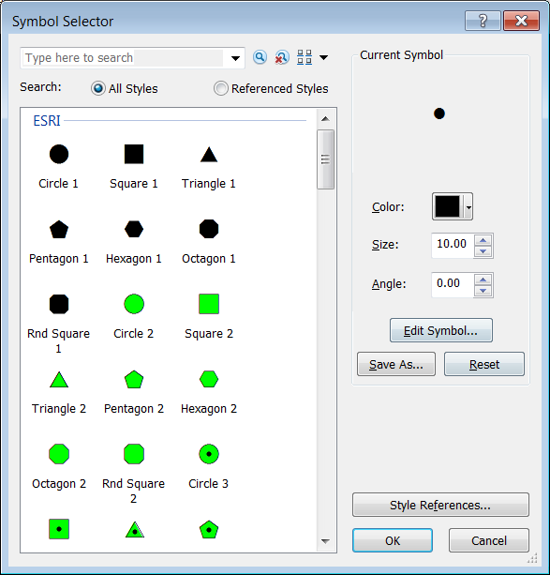**Change the **Value Field** to **POP\_CLASS** and click on the **Add All Values** button.
4. **Uncheck** the **<all other values>** item and **double-click** on **symbol to the left** of the “**1,000,000 to 4,999,999**” item.
5. In the resulting Symbol Selector, select **Circle 1** and change its size to **4 points**. Click OK.
6. Using the same method, change the symbol for the “**5,000,000 and greater**” item to **Circle 1** with a size of **10 points**.
7. **Click OK** to close the Properties Window and commit the changes to symbology.
8. **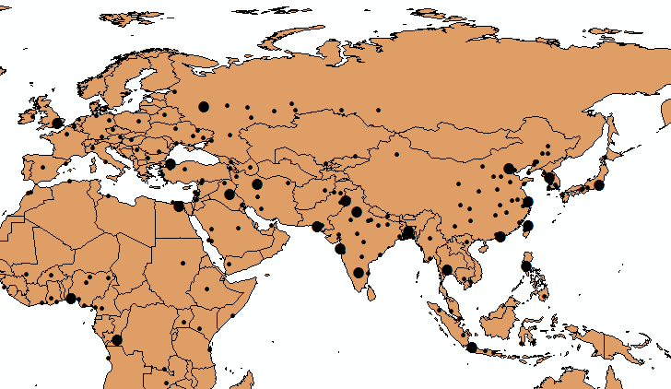Click Save**

#### Label Cities

***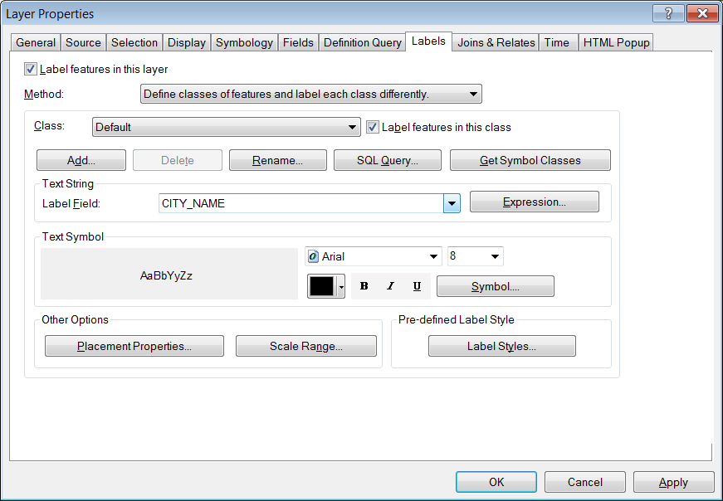***Another property of the layers in our Map Document that we might want to enable is the labeling of features. This can be accomplished, based upon an attribute value for each of the features. In many cases, this might be the name, or some other identifying attribute of the feature, but in some cases it might be a quantitative value associated with the features. It is even possible to use VB Scripting to assemble labels from several attributes and text elements. In this example, we will label only the cities with a POP\_RANK value of 1.

1. **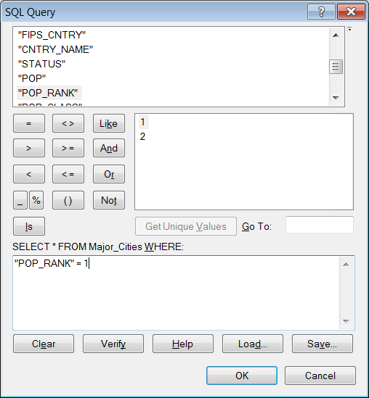Right-Click** on the **Major\_Cities Layer** and select **Label Features**.

Note that this turns on labels for all features and, by ArcMap selects a field containing names, by default. Because there are so many visible features in this layer, this creates an unreadable labeling scheme. To remedy this, we will limit labeling to the largest cities in the Major Cities Layer.

1. **Right-click** on the **Major\_Cities** **Layer** and select **Properties**. **Click** on the **Labels Tab**.
2. **Change** the **Method** to “**Define classes of features and label each class differently**”
3. **Click** on the **SQL Query**… button.
4. 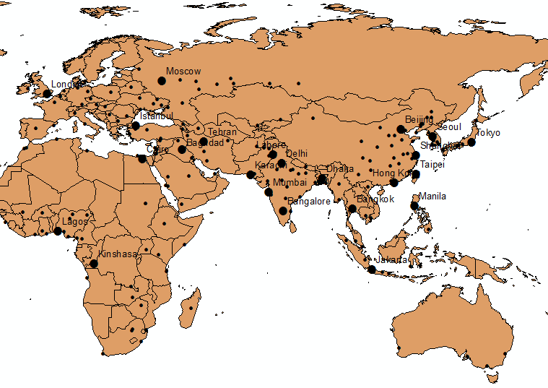In the **SQL Query** window, create a **SELECT argument** as follows:  
   **“POP\_RANK”=1**
5. **Click OK**
6. **Change** the **Label Size** to **12 points** and **Click OK** to apply this labeling scheme to the Data Frame.

### Join a Table to a Layer

Now we will turn our attention to the World\_Countries Layer. Ultimately, we would like to visualize the layer based upon population density. However, the attribute table for this layer doesn’t contain data on population. Fortunately we have a table in our Map Document with the necessary population attribute.

1. **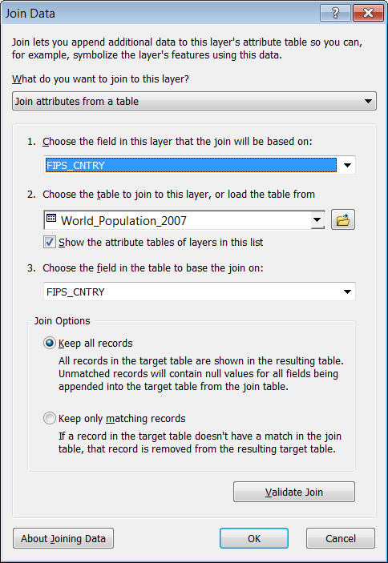Change** the **Table of Contents** to the **List by Source** view so that the **World\_Population\_2007 Table** is visible.
2. **Right-click** on the **World\_Population\_2007 Table** and select **Open**.
3. Scroll through the attributes and note the **FIPS\_CNTRY** Attribute Field. **Close** the **table**
4. **Open** the **Attribute Table** for the **World\_Countries Layer** and note that it also has a **FIPS\_CNTRY** Attribute Field.

Since this attribute exists in both of these attribute tables, and its values are identical across the two datasets, we can use this attribute as the “**Key Field**” for our table join.

1. **Close** the **Attribute Table** for the **World\_Countries Layer.**
2. **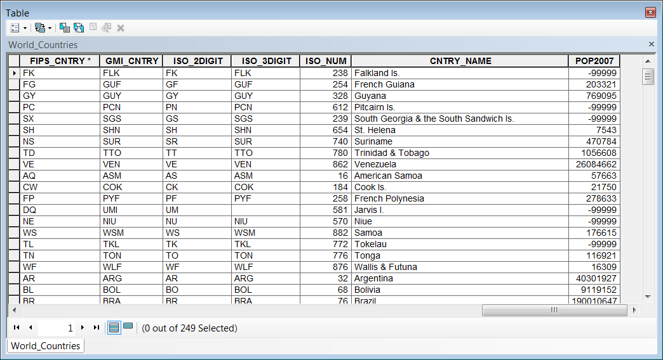Right Click** on the **World\_Countries Layer** and **Select Joins and Relates>Join…**
3. **Select** **FIPS\_CNTRY** as the **Join Field** for the **World\_Countries Layer**.
4. If it is not selected automatically, **select** **World\_Population\_2007** as the **Table** to join to the **World\_Countries Layer**, and **FIPS\_CNTRY** as the **Join Field** for this table.
5. **Click OK** to create the Join.
6. **Open** the **Attribute Table** for the **World\_Countries Layer** and note the **POP2007 Attribute (along with all other attributes from the World\_Population\_2007 table).**

### Definition Querys

You may have noticed that many of the features in the World\_Countries Layer had values of **-99999** for the POP2007 attribute. This normally indicates **NODATA** for the particular feature in demographic datasets. In this case, we would like to exclude this value from our Map Document. We could use the method used to subset the Cities layer earlier in the tutorial, but this time we will use another method called Definition Query. Definition Queries “define” a dataset, based upon a SQL Query, like the ones we have used to create the selection by attributes and the labeling class. In this case, the Definition Query “defines” a subset of the data layer that ArcMap treats as the entirety of the dataset. It does not, however, require creating a new dataset (preventing redundancy in data storage) and does not alter the dataset being referenced, only our view of it in ArcMap.

1. **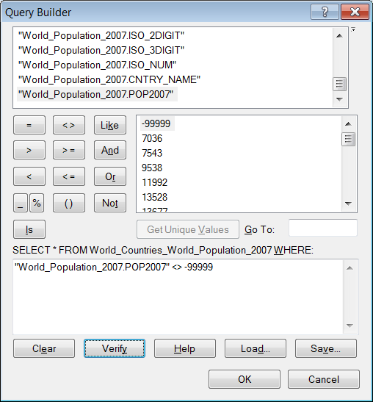Right-click** the **World\_Countries** **Layer** and open its **Properties**.
2. **Click** on the **Definition Query Tab**.
3. **Click** on the **Query Builder Button** and create a **SELECT Argument** as follows:  
     
   **“World\_Population\_2007.POP2007”<>-99999**
4. **Click OK Twice** to **apply** the **Definition Query**.
5. **Open** the **Attribute Table** for the **World\_Countries Layer** and ***note that the POP2007 Field no longer contains records with -99999 as a value.***

Because most of the features with this value are lesser countries (in terms of area) it may not be apparent that the corresponding geographic features have also been removed from the Layer, as well.

#### C:\Users\sdm53\Pictures\ScreenCaps\EX01_World_Pop\47 Pop Density Symbology.pngSymbolize Countries by Population Density

We can now use the POP2007 attribute to visualize population density. Even though the POP2007 variable is a raw counts variable, we can use the Symbology Tabs Normalization capability to divide the POP2007 variable by the area of the features to create the density value on-the-fly.

1. **Open** the **Properties** for the **World\_Countries Layer** and click on the **Symbology Tab**.
2. **Select** **Quantities** and set the **Value** to the **POP2007** variable.
3. **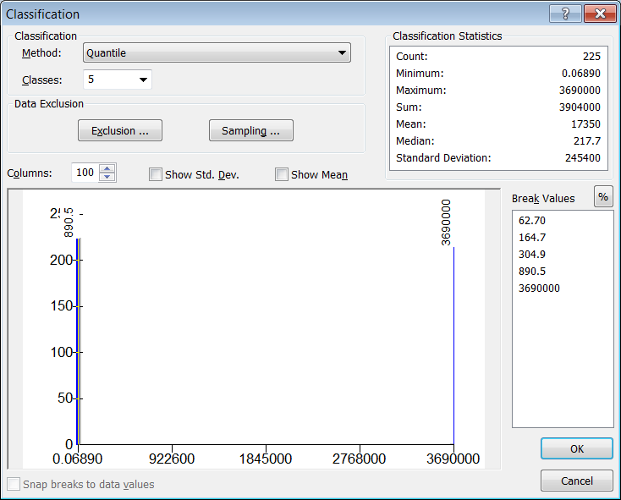**Set the **Normalization** Field to the **SQMI** field.
4. **Click** on the **Classify**… Button and set the **Classification** **Method** to **Quantiles** with **5 Classes**.
5. **Click OK**.
6. **Select** a **Color Ramp** and **Click OK** to **apply** the **Symbology**.

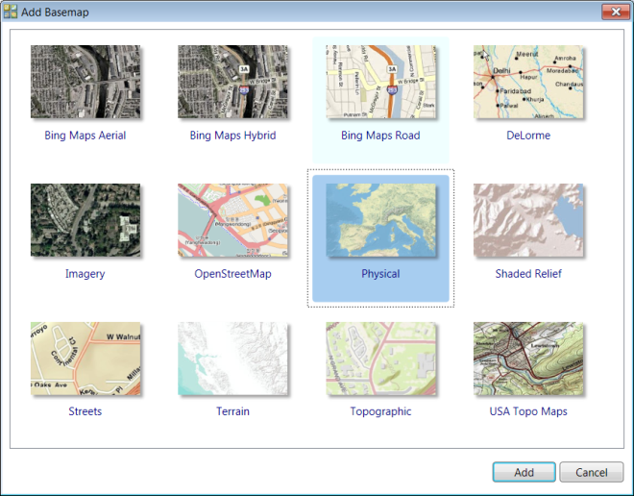*Note: When selecting your color ramp, be careful about selecting anything other than monochrome color ramps. This is because you want your map to “read well” in grayscale. In some of the 2-3 color ramps, the* ***Intensity value*** *of the colors at each end of the spectrum is the same, so that they produce identical grayscale values when converted, Xeroxed or printed in black & white.*

### Adding “Cloud” Data

Often, you will want to provide a cartographic basemap for your data in order to give it geographic context. Cartographic design can be quite time consuming. Fortunately, ArcMap leverages “Cloud” technologies to make a wide variety of pre-designed cartographic basemap layer available over the internet for use in your Map document.

1. On the **Main Menu**, go to **File>Add Data>Add Basemap**.
2. In the resulting window, select the **“Oceans”** **basemap**, and **click** **Add**.
3. **Uncheck** the **Reference Layer** that is added to the top of the **Table of Contents**.
4. Wait for the basemap to render and **save your work.**

## Layout Mode

### The Layout Mode Navigation Tools

1. Using the **View Toolbar** at the **bottom left corner** of the **Data Frame**, switch to **Layout Mode**.

Note that the Layout Toolbar is now active and that many of the tools on this toolbar look similar to those on the Tools Toolbar, with one very important difference. Now that you are in Layout Mode, your view has changes so that your Data Frame is now superimposed upon piece of paper (the size of which is determined by the default printer paper size for the printer connected to your machine). The tools on Tools Toolbar act (as they did in the Data View) *within* the Data Frame, while the analogous tools on the Layout Toolbar act upon the Page Layout (without effecting the Data Frame extent or scale).

1. Take a moment to **explore the differences** between how the **Layout Toolbar** behaviors differ from the **Tools Toolbar** navigation tools.

### C:\Users\sdm53\Pictures\ScreenCaps\EX01_World_Pop\52 Data Fram Size.pngResize Data Frame

For the time being, we will not concern ourselves with the Page Orientation of our Map Document. In this case, we will assume we are creating a map image, not for printing, but for inclusion in a Word Document or Presentation. In that case, we will want to alter the size of the Data Frame to the size we desire for our final image.

1. **Right-click** on the **Layers** item at the top of the Table of Contents and open the **Properties for the Data Frame.**
2. **Click** on the **Size and Position Tab** and set the **Frame Size** as **7 in wide by 4 in**.
3. **Click** on the **Frame Tab** and set the **Border weight** to **4 points**.
4. 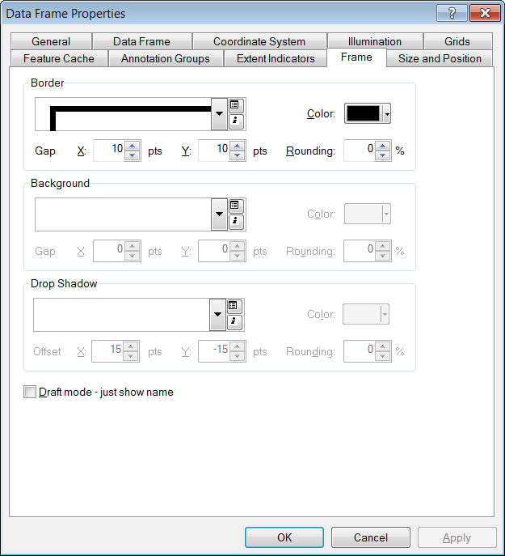Assign a **Gap** of **10 pts** for **both the X and Y axes**.
5. **Click OK** to apply the changes
6. On the **Main Menu**, go to **Bookmarks** and select your **Europe & Asia** bookmark
7. Use the Tools Toolbar navigation tools to **zoom and pan** until Africa and the Eurasian continents **fill the Data Frame**.

### Adding Map Elements

#### Legend

1. On the **Main Menu**, go to **Insert>Legend**
2. **Select** **and** **remove** all ***EXCEPT*** the **Major\_Cities** and **World\_Countries** layers from the **Legend Items** **list** and **click Next>** **twice**.

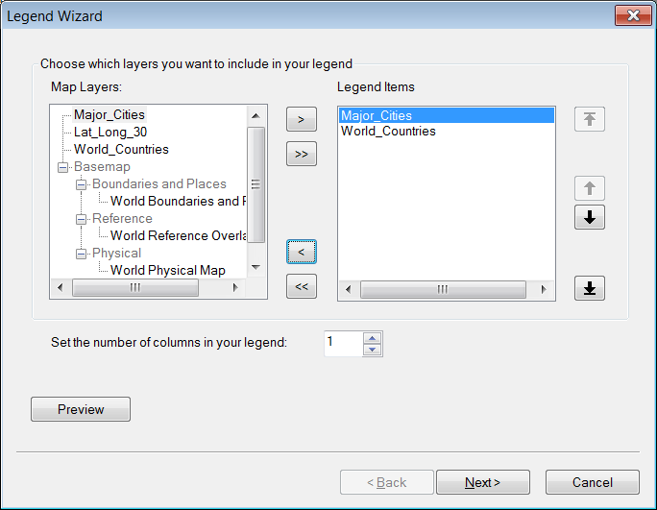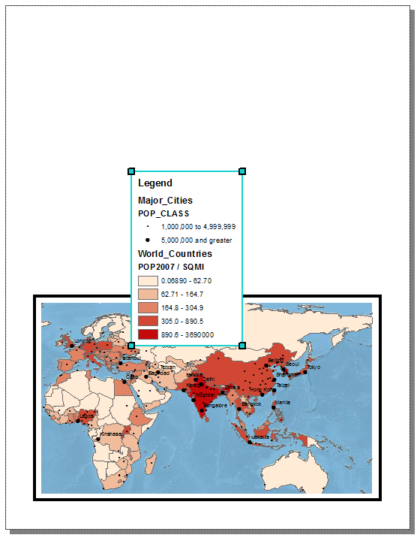

1. Give the **Legend** a **Border** and **Background** (white is a good choice).
2. **Click Next>** to **accept all remaining default settings** and insert the Legend.
3. Use the **Select Elements Tool** to **resize** and **reposition** the **Legend** using the blue resize handles.
4. **Click** once on the **Major\_Cities Layer**, wait a few seconds, and then **click again** to **highlight** the **Layer Name for Editing**. **Rename** the **Layer** “**Major Cities**” removing the underscore, and **hit the Enter key** to commit the change.

*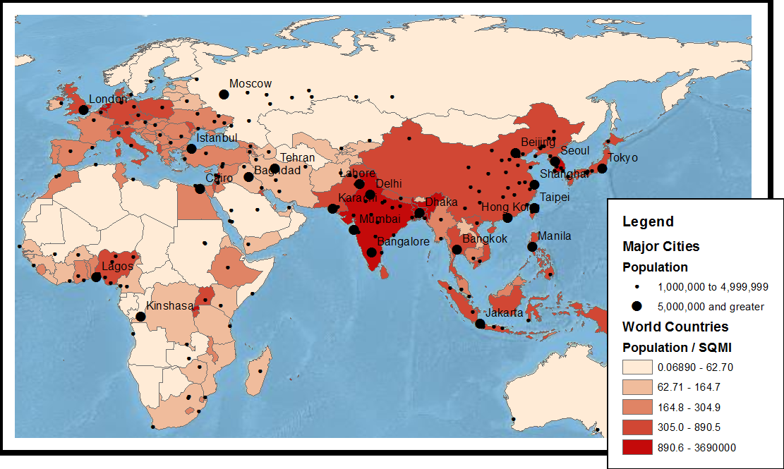Note that the change you have made to the name of the Layer is also reflected in the Legend*.

1. Make changes to the other Text Elements of your Layers so that your Legend contains properly formatted and reasonable text descriptions and labels.

#### *C:\Users\sdm53\Pictures\ScreenCaps\EX01_World_Pop\59 scale bar properties.png*Scale Bar

1. On the **Main Menu**, go to **Insert>Scale Bar**
2. Select **Scale Line 1** from the Scale Bar Selector and click on the **Properties** Button.
3. Set the **Number of Divisions** to **1** and the **Subdivisions** to **0**.
4. Change the **Division Units** to **Miles**.
5. Click on the **Numbers and Marks Tab**.
6. Set the **Numbers and Marks Frequencies** to “**ends (and zero)**”
7. Click **OK** twice to add the scale bar to the Map Layout.
8. Use the **Select Elements Tool** to **resize** and **reposition** the **Scale Bar**.

#### Neat Line

1. 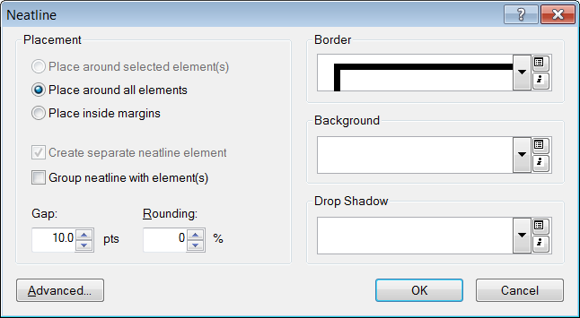On the **Main Menu**, go to **Insert>Neatline**.
2. Be sure that the “**Place around all elements**” **option** is checked.
3. Set the **Border Size** to **4 points**.
4. **Click OK** to add the **neatline**.

## Exporting Your Map

1. **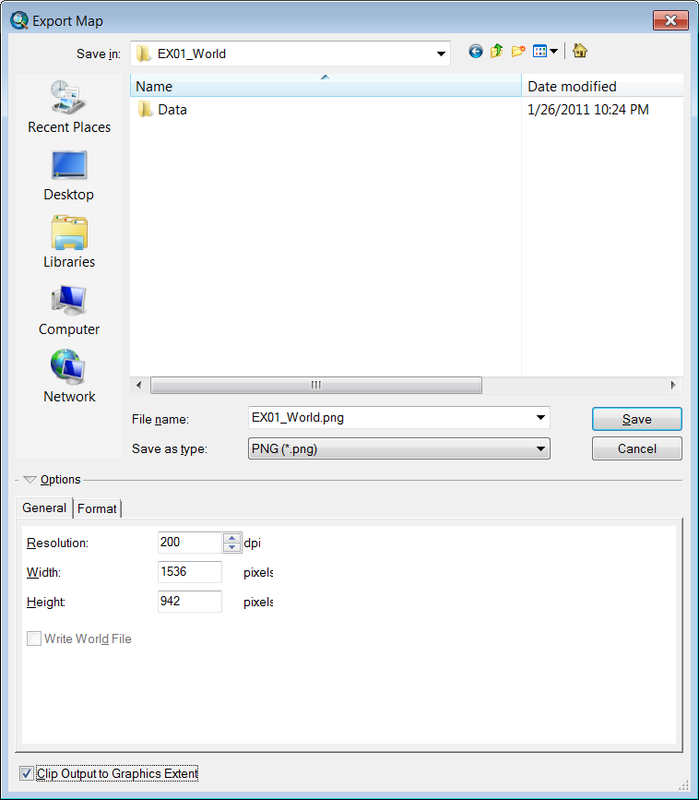Save your Work**.
2. On the **Main Menu**, go to **File>Export Map…**
3. **Click** on the **Home Button** to browse to the Workshop Folder.
4. **Change** the **Save as type** to **PNG(\*.png)**
5. **Change** the **Resolution** to **200 dpi**
6. **Check** the **option** to “**Clip Output to Graphics Extent**”
7. **Click Save**.
8. **Browse** to the Workshop Folder and double click on the **EX01\_World.png** file to view it in the default image viewer.

